06/09/2024

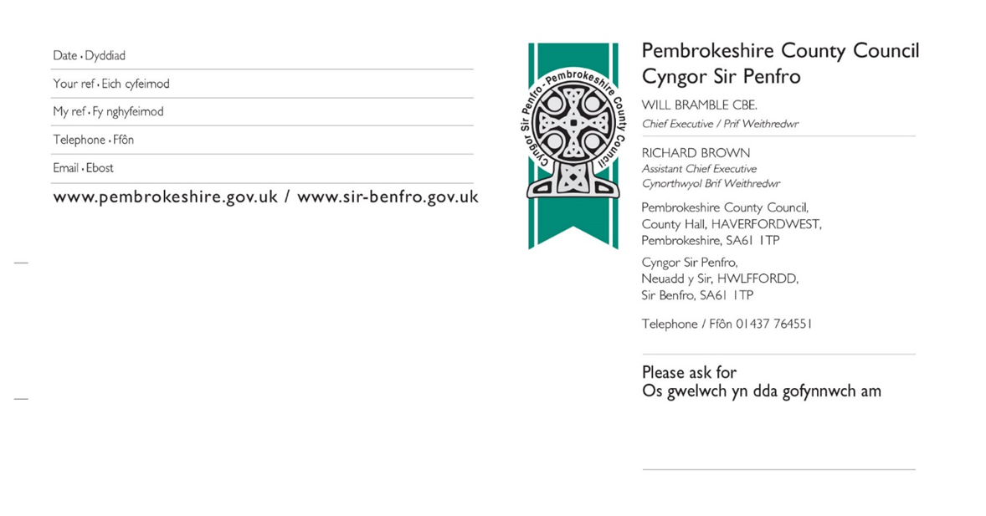

24/0241/PA

01437 764551

[Planning.support.team@pembrokeshire.gov.uk](mailto:Planning.support.team@pembrokeshire.gov.uk)

Ms J Thomas (Clerk),

Jeffreyston Community Council

38, John Street

NEYLAND

Milford Haven

Pembrokeshire

SA73 1TH

Dear Sir/Madam

Lucy Whitby

**NOTIFICATION OF PLANNING DECISION**

**This is a notification of a planning decision. The decision notice shall be published to the Authority’s website shortly.** [**Please click here to view the application documents**](https://planning.agileapplications.co.uk/pembrokeshire/application-details/41476)

|  |  |  |  |  |
| --- | --- | --- | --- | --- |
| **Proposal:** | **Part retrospective planning for stables, tack room & hay store** | | | |
| **Site Address:** | **Land near Norchard Farm, REDBERTH, Tenby, Pembrokeshire, SA70 8RX** | | | |
| **Grid Reference:** | **0-0** | | | |
| **Date Received:** | **13-Jul-2024** |  |  |  |
| **Decision:** | **Conditionally Approved** |  | **Date Decided:** | **06-Sep-2024** |

Yours faithfully

DEVELOPMENT MANAGEMENT SECTION

Please quote the reference number **24/0241/PA** in all enquiries and correspondence with this Authority in respect of this Planning Application.

*Our Planning and Building Control website is changing in January. The new system will make it easier to search for and track applications. There may be some disruption to the service over this period but we hope this will be kept to a minimum.*

*Bydd ein gwefan Cynllunio a Rheoli Adeiladau yn newid ym mis Ionawr. Bydd y system newydd yn ei gwneud hi’n haws chwilio am geisiadau a’u holrhain. Efallai y bydd rhywfaint o darfu ar y gwasanaeth dros y cyfnod hwn ond rydym yn gobeithio y bydd cyn lleied o broblemau â phosibl*

We welcome correspondence in Welsh and English, and will respond within a maximum of 15 working days. We will respond in the language in which the correspondence is received (unless you ask us to do otherwise).*/* Rydym yn croesawu gohebiaeth yn Gymraeg a Saesneg a byddwn yn ymateb cyn pen 15 diwrnod gwaith fan bellaf. Byddwn yn ymateb yn yr un iaith â’r ohebiaeth a dderbyniwyd (oni bai eich bod yn gofyn i ni wneud yn wahanol).

For a copy in large print, easy-read, Braille, audio, or an alternative language, please contact Pembrokeshire County Council on the number above. / Os am gopi mewn print mawr, fformat hawdd ei ddarllen, Braille, sain neu mewn iaith arall, cysylltwch â Chyngor Sir Penfro ar y rhif uchod.